Changing the Colors of Elements in the Viewport
12/7/2026
Edit → Preferences → Themes → 3D Viewport
Wire changes the color of the Parent line.
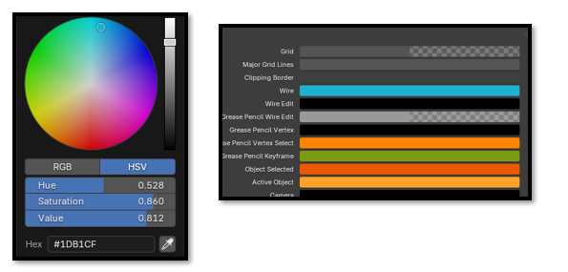
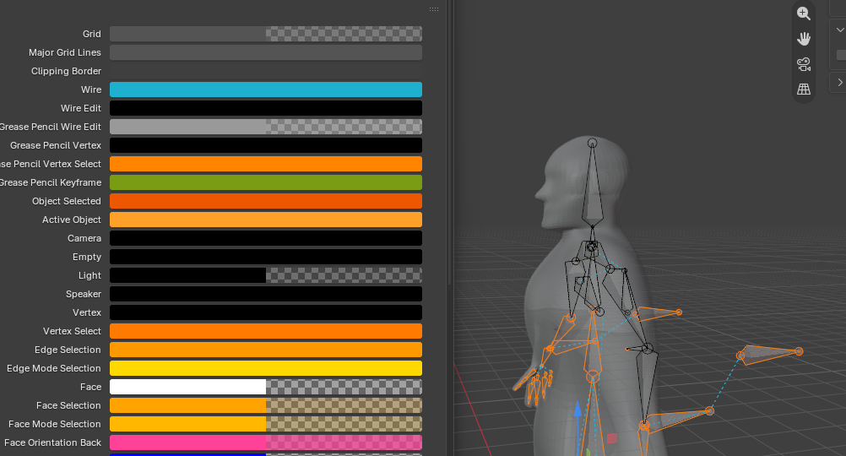
Watch it, this setting will also change the outline of the bones in edit mode, if you make the color bright red, whenever you view the bones, you might think “Oh No, red I must have done something wrong”
This Teal color works for both the parenting and the armature
